FUNCTIONAL SPECIFICATION FOR THE INTERNATIONAL LRIT DATA CENTRE
PROPOSED DOCUMENT LAYOUT

TABLE OF CONTENTS
1. General Provisions
General
General description of the system
Definitions
2. International LRIT Data Centre Description
International LRIT Data Centre Block Diagram
System Functions
Description of the general functionality of the International LRIT Data Centre
LRIT Information Reporting
3. System Architecture / High Level Design
This section will describe a high-level overview of the system architecture including a data flow diagram.
4. Functional Requirements
- requirements
Overview
Type of Requirements
List of Functional Requirements
- Use case model
Overview/introduction
Actor catalogue
Use case catalogue (e.g. Polling request, send notification, receive data distribution plan update)

FUNCTIONAL SPECIFICATION FOR THE INTERNATIONAL LRIT DATA CENTRE
1 General Provisions
1.1 General
1.1.1 The Maritime Safety Committee, at its eighty-first session in May 2006, adopted amendments to chapter V of the SOLAS convention in relation of LRIT. These amendments will come into force on the first of January 2008 provided that acceptance criteria have been fulfilled by the first of July 2007.
1.1.2 The Long-Range Identification and Tracking (LRIT) system provides for the global identification and tracking of ships.
1.1.3 The International LRIT Data Centre is an element of the International LRIT System that receives, stores and disseminates LRIT information on behalf of Governments. In the context of the LRIT system architecture, this document addresses the functional specifications for the International LRIT Data Centre.
1.1.4 In operating the LRIT system, recognition shall be given to international conventions, agreements, rules or standards that provide for the protection of navigational information.
1.1.5 The International LRIT Data Centre shall be established and recognized by the Committee
1.1.6 The International LRIT Data Centre shall be capable of receiving and processing LRIT information from all ships, other than those which are required to transmit LRIT information to a National, Regional or Co-operative LRIT Data Centre.
1.2 General description of the system
1.2.1 The LRIT system consists of the shipborne LRIT information transmitting equipment, the Communication Service Provider(s), the Application Service Provider(s), the LRIT Data Centre(s), including any related Vessel Monitoring System(s), the LRIT Data Distribution Plan and the International LRIT Data Exchange. Certain aspects of the performance of the LRIT system are reviewed or audited by an LRIT Co-ordinator acting on behalf of all Contracting Governments. Figure 1 provides an illustration of the LRIT system architecture.
1.3 Definitions
1.3.1 The following definitions apply to the International LRIT Data Centre and are taken from the Performance Standards and functional Requirements for LRIT:
1.3.1.1 Convention means the International Convention for the Safety of Life at Sea, 1974, as amended.
1.3.1.2 Regulation means a regulation of the Convention.
1.3.1.3 Chapter means a chapter of the Convention.
1.3.1.4 LRIT Data User means a Contracting Government or a Search and rescue service which opts to receive the LRIT information it is entitled to.
1.3.1.5 Committee means the Maritime Safety Committee.
1.3.1.6 High-speed craft means a craft as defined in regulation X/1.3.
1.3.1.7 Mobile offshore drilling unit means a mobile offshore drilling unit as defined in regulation XI-2/1.1.5.
1.3.1.8 Organization means the International Maritime Organization.
1.3.1.9 Vessel Monitoring System means a system established by a Contracting Government or a group of Contracting Governments to monitor the movements of the ships entitled to fly its or their flag. A Vessel Monitoring System may also collect from the ships information specified by the Contracting Government(s) which has established it.
1.3.1..10 LRIT information means the information specified in SOLAS regulation V/19-1.5.
1.3.1.11 The term .ship., when used in the present Performance standards and functional requirements for long-range identification and tracking of ships (the Performance standards),includes mobile offshore drilling units and high-speed craft as specified in regulation V/19-1.4.1 and means a ship which is required to transmit LRIT information.
1.3.1.12 Terms not otherwise defined should have the same meaning as the meaning attributed to them in the SOLAS Convention.
2 International LRIT Data Centre Description
2.1 International LRIT Data Centre Block Diagram
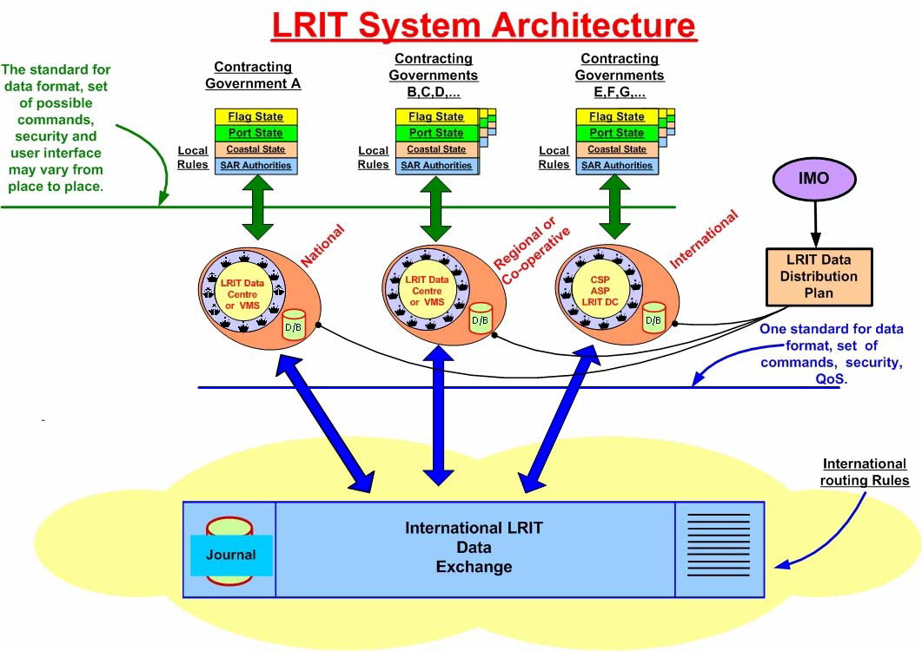
2.2 System Functions
2.2.1 Description of the general functionality of the International LRIT Data Centre
2.3 LRIT Information Reporting
2.3.1 Data Requirements
Shipborne units will transmit position, identification and time.
be capable of automatically and without human intervention on board the ship transmitting the ship’s LRIT information at 6-hour intervals to an LRIT Data Centre;4.2 In addition to the provisions specified in paragraph 4.1 above, the shipborne equipment shall provide the functionality specified in table 1.
ADDRESS SYSTEM CAPACITY…
The International LRIT Data Centre shall be capable of processing 50,000 SOLAS Class ships. Based on the requirement for ships to transmit LRIT information four times per day, this results in 50,000 x 4 reports per day = 200,00 reports per day.
TABLE 1
DATA TO BE TRANSMITTED FROM THE SHIPBORNE EQUIPMENT

Parameter | Comments
Shipborne equipment Identifier | The identifier used by the shipborne equipment.
 | The GNSS position (latitude and longitude) of the ship (based on the WGS84 datum).
 | Position: The equipment shall be capable of transmitting the GNSS position (latitude and longitude) of the ship (based on WGS84 datum) as prescribed by regulation V/19-1, without human interaction on board the ship.
Positional data | On-demand⁽¹⁾position reports: The equipment shall be capable of responding to a request to transmit LRIT information on demand without human interaction onboard the ship, irrespective of where the ship is located.
 | Pre-scheduled⁽²⁾position reports: The equipment shall be capable of being remotely configured to transmit LRIT information at intervals ranging from a minimum of 15 minutes to periods of 6 hours to the LRIT Data Centre, irrespective of where the ship is located and without human interaction on board the ship.
Time Stamp 1 | The date and time⁽³⁾associated with the GNSS position. The equipment shall be capable of transmitting the time⁽³⁾associated with the GNSS position with each transmission of LRIT information.
Notes: | (1) On-demand position reports means transmission of LRIT information as a result of either receipt of polling command or of remote configuration of the equipment so as to transmit at interval other than the preset ones.
 | (2) Pre-scheduled position reports means transmission of LRIT information at the preset transmit intervals.
 | (3) All times shall be indicated as Universal Co-ordinated Time (UTC).

3 System Architecture / High Level Design
This section will describe a high-level overview of the system architecture including a data flow diagram.
International LRIT Data Centre Block Diagram
3.1 Top Level Block Diagram Description [More to come…this is a placeholder][Deleted previous placeholder and inserted IDC block diagram provided by Olaf]
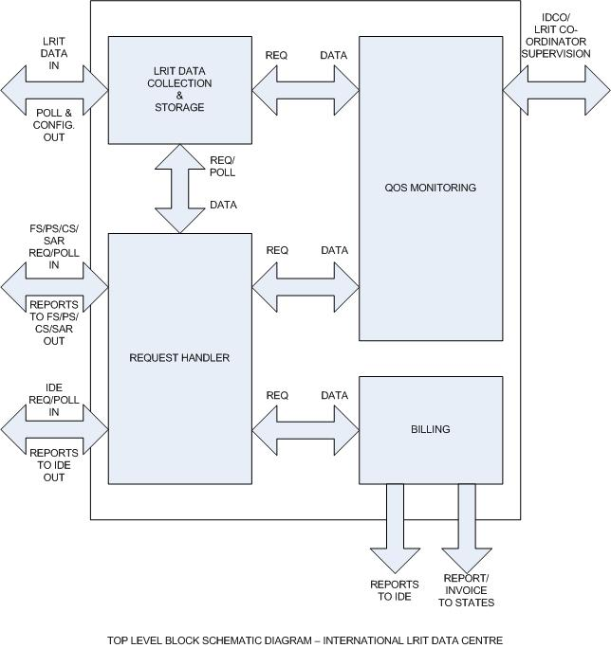

4 Functional Requirements
4.1 requirements
Overview
Type of Requirements
List of Functional Requirements
The International LRIT Data Centre shall receive, store and disseminate LRIT information. The International LRIT Data Centre shall:
- Perform authentication based on the LRIT Data Distribution Plan. establish and continuously maintain systems which ensure, at all times, that LRIT Data Users are only provided with the LRIT information they are entitled to receive as specified in regulation V/19-1;
- Receive LRIT information from ships instructed by their Administrations to transmit the LRIT information to the centre;
.3 when requested, provide LRIT information transmitted by ships other than those which transmit the information to the centre, LRIT information from other LRIT Data Centres through the International LRIT Data Exchange;
.4 make available, when requested to provide LRIT information transmitted by ships other than those which transmit the information to the centre, LRIT information transmitted to the centre to other LRIT Data Centres through the International LRIT Data Exchange;
.5 execute requests received from LRIT Data Users for polling of LRIT information or for change(s) in the interval(s) of transmission of LRIT information by a ship or a group of ships transmitting the information to the centre;
.6 relay, when required, requests received from LRIT Data Users through the International LRIT Data Exchange to the other LRIT Data Centres for polling of LRIT information or for change(s) in the interval(s) of transmission of LRIT information by a ship or a group of ships not transmitting the information to the centre;
.7 execute requests received through the International LRIT Data Exchange from other LRIT Data Centres for polling of LRIT information or for change(s) in the interval(s) of transmission of LRIT information by a ship or a group of ships transmitting the information to the centre;
.8 upon request disseminate to LRIT Data Users the LRIT information they are entitled to receive in accordance with the agreed arrangements and notify the LRIT Data User and the Administration when a particular ship stops transmitting LRIT information;
.9 archive LRIT information from ships which transmit the information to the centre, for at least one year and until such time as the Committee reviews and accepts the annual report of the audit of its performance by the LRIT Co-ordinator. However, the archived LRIT information shall provide a complete record of the activities of the centre between two consecutive annual audits of its performance;
.10 Perform database storage and retrieval in accordance with the following schedule:
.1 for LRIT information archived within the last 4 days, send the LRIT information within 30 minutes of receiving a request;
.2 for LRIT information archived between 4 and 30 days previously, send the LRIT information within 1 hour of receiving a request;
.3 for LRIT information archived more than 30 days previously, send the LRIT information within 5 days of receiving a request;
.11 ensure using appropriate hardware and software, that LRIT information is backed-up at regular intervals, stored at suitable off-site location(s) and available as soon as possible in the event of disruption to ensure continuity of service;
.12 maintain a record of the ships which transmit LRIT information to the centre including name of ship, IMO Ship identification number, Call Sign and Maritime Mobile Service Identity (MMSI);
.13 use a secure authentication method with LRIT Data Users;
14, 15 Refer to Comms….
.14 use a standard and expandable message format for communicating with the International LRIT Data Exchange;
.15 use reliable connections (e.g. TCP) to ensure that the LRIT information is successfully received by the LRIT Data Centres; and
.16 add the appropriate data identified in table 2 to each transmission of LRIT information collect by the centre.
.17 The performance of the International LRIT Data Centre shall be audited by the LRIT Co-ordinator. Complete later with detailed specification.
.18 Provide to the LRIT Co-ordinator the information required to enable the satisfactory completion of an audit of their performance.
.19 provide to Search and rescue services (SAR services), LRIT information transmitted by all ships located within the geographic area specified by the SAR service requesting the information so as to permit the rapid identification of ships which may be called upon to provide assistance in relation to the search and rescue of persons in distress at sea. The LRIT information shall be provided irrespective of the location of the geographic area and shall be provided even if the geographic area is outside the search and rescue region associated with the SAR service requesting the information (regulation V/19-1.12 refers).
.20 The International LRIT Data Centre shall interface to the International Data Exchange.
.21 The International LRIT Data Centre shall respond to all queries from all data centres through the data exchange.
.22 Maintain a current list of Ships within the International LRIT Data Centre (eg. Change of flag, taken out of service).
International LRIT Data Centre system security
The International LRIT Data Centre shall verify communications and provide for data security using methods such as Authorization; Authentication; Confidentiality; Integrity and as specified in the LRIT Communications Specification.

International LRIT Data Centre system performance
LRIT information shall be available to an LRIT Data User within 15 minutes of the time it is transmitted by the ship. AVAILABILITY
On-demand LRIT information reports shall be provided to an LRIT Data User within 30 minutes of the time the LRIT Data User requested the information.

The quality of service:  Number of delivered reports meeting latency requirements  Total number of report requests | x 100%

 | 95% of the time over any 24-hour period; and 99% over any 1 month.
Interfaces/Interaction:
Application Service Providers: The International LRIT Data Centre shall interact with Communications Service Providers through a communications protocol provided by an Application Services Provider to enable the following minimum functionality:
- remote integration of the shipborne equipment into the International LRIT Data Centre;
- automatic configuration of transmission of LRIT information;
- automatic modification of the interval of transmission of LRIT information
- automatic suspension of transmission of LRIT information; on demand transmission of LRIT information; and
- automatic recovery and management of transmission of LRIT information
- provide an integrated transaction management system for the monitoring of LRIT information throughput and routeing; and
- ensure that LRIT information is collected, stored and routed in a reliable and secure manner.
The International LRIT Data Centre shall be capable of receiving and processing the data in Table 2 added by an ASP (where used) to each transmission of LRIT information:
TABLE 2
DATA TO BE ADDED BY AN APPLICATION SERVICE PROVIDER
AND AT THE LRIT DATA CENTRE

Parameters |  | Comments
Ship Identity(1) |  | The IMO ship identification number⁽¹⁾and MMSI for the ship.
Time Stamp 2 |  | The date and time⁽²⁾the position report is received by the ASP (if used).
Time Stamp 3 |  | The date and time⁽²⁾the position report is forwarded from the ASP (if used) to the appropriate LRIT Data Centre.
LRIT Data Centre Identifier |  | The identity of the LRIT Data Centre to be clearly indicated by a Unique Identifier.
Time Stamp 4 |  | The date and time⁽²⁾the position report is received by the LRIT Data Centre.
Time Stamp 5 |  | The date and time⁽²⁾the position report is forwarded from the LRIT Data Centre to an LRIT Data User.
 | Notes: | (1) See regulation XI-1/3 and Assembly resolution A.600(15) on IMO ship identification number scheme.
 |  | (2) All times should be indicated as Universal Co-ordinated Time (UTC).

Authentication table - ASP to International data centre…

LRIT Data Users: Flag, Port, Coastal States, SAR Authorities
An International LRIT Data Centre may, upon request, collect additional information from ships entitled to fly the flag of an Administration on the basis of specific arrangements concluded with the Administration concerned.
The International LRIT Data Centre shall provide requested LRIT information in relation to the search and rescue of persons in distress at sea.

Administrations
The International LRIT Data Centre shall be made available to all Administrations.
The following information shall be received and recorded at the International LRIT Data Centre for each participating Administration:
- Name of ship;
- IMO Ship identification number;
- Call Sign; and
- Maritime Mobile Service Identity.
Amend the information above upon the transfer of a Flag of a Ship and to include the following:
.1 The effective date and time (UTC) of transfer; and
.2 The State whose the flag the ship was formally entitled to fly, if known.

Contracting Governments
Under the provisions of regulations V/19.1 (attached as Annex “ “ herein), the International Data Centre shall provide requested LRIT information to Contracting Governments in the LRIT Data Distribution Plan if:
- it is entitled to under the provisions of regulation V/19-1;
- the LRIT data centre shall verify the validity of all requests for information against the criteria established in the regulation V/19-1. If so decided, the Contracting Government may give the International LRIT Data Centre a standing order regarding the criteria for receiving LRIT information.
- The Data Centre shall compare requests for LRIT information against the criteria in the Data Distribution Plan and any standing orders which it has received;
Other LRIT Data Centres: National, Regional and Co-operative
International LRIT Data Exchange
TO BE REVIEWED! If a National, Regional or Co-operative LRIT Data Centre collects additional information from ships, it shall transmit only the required LRIT information to the other LRIT Data Centres through the International LRIT Data Exchange.
The International LRIT Data Centre shall interface to the International Data Exchange.
LRIT Data Distribution Plan
LRIT Co-ordinator
The LRIT Co-ordinator will be appointed by the Committee and shall perform the following administrative functions:
.1 participate in the testing of new or modified procedures or arrangements for communications between the International LRIT Data Exchange and the International LRIT Data Centre and provide relevant information to the Committee
.2 – ADD TO DEVELOPMENTAL TESTING.
As required by the LRIT Co-ordinator, the International LRIT Data Centre shall:
.1 Grant access to the LRIT Co-ordinator for management, charging, technical and operational data;
.2 Compile statistics for the LRIT Co-ordinator.
In addition to reporting to the Committee on the performance of the LRIT system including any identified non-conformities, the LRIT Co-ordinator shall make recommendations to the Committee, based on an analysis of its findings, with a view to improving the efficiency, effectiveness and security of the LRIT system.
Establish a mechanism to charge appropriate fees to contracting government for the LRIT information they request and receive.
The LRIT Co-ordinator shall assist in the establishment of the International LRIT Data Centre and International LRIT Data Exchange by:
.2 issuing requests for the submission of proposals for the establishment and operation of the International LRIT Data Centre and International LRIT Data Exchange;
.4 participating in the initial developmental testing of the LRIT system and reporting its findings in this respect for consideration by the Committee.
The LRIT Co-ordinator shall perform the following administrative functions:
.2 participation in the testing for the integration of new LRIT Data Centres into the LRIT system and providing relevant information to the Committee; and
The LRIT Co-ordinator shall undertake a review of the performance of the LRIT system taking into account the provisions of regulation V/19-1, the present Performance standard and any related decisions of the Committee and shall report its findings to the Committee at least annually. In this respect, the LRIT Co-ordinator shall:
.1 review the performance of Application Service Providers (or Communication Service Providers when they act as Application Services Providers) providing services to the International LRIT Data Centre;
.2 audit the performance of all LRIT Data Centres based on archived information and their fee structures;
.3 audit the performance of the International LRIT Data Exchange and its fee structure, if any; and
.4 verify that Contracting Governments and Search and rescue services receive the LRIT information they have requested and are entitled to receive.

  - Use case model
Overview/introduction
Actor catalogue
Use case catalogue (e.g. Polling request, send notification, receive data distribution plan update)
[The Block LRIT Specification and Description Language diagram provided by Olaf follows. Is this the right location for this?] [Should this section provide the SDL details?]

The detailed description of the International LRIT Data Centre shall include a set of SDL (Specification and Description Language) diagrams or other suitable Event-Based Architecture Description Language intended for complex software systems.

