TECHNICAL SPECIFICATIONS FOR THE INTERNATIONAL LRIT DATA CENTRE
1 General Provisions
This document is intended as a supplement to the Performance Standard MSC.210(81)
1.1 General
1.1.1 The Maritime Safety Committee, at its eighty-first session in May 2006, adopted amendments to chapter V of the SOLAS convention in relation of LRIT. These amendments will come into force on the first of January 2008 provided that acceptance criteria have been fulfilled by the first of July 2007.
1.1.2 The Long-Range Identification and Tracking (LRIT) system provides for the global identification and tracking of ships.
1.1.3 The International LRIT Data Centre is an element of the International LRIT System that receives, stores and disseminates LRIT information on behalf of Governments. In the context of the LRIT system architecture, this document addresses the functional specifications for the International LRIT Data Centre.
1.1.4 In operating the LRIT system, recognition shall be given to international conventions, agreements, rules or standards that provide for the protection of navigational information.
1.1.5 The International LRIT Data Centre shall be established and recognized by the Committee
1.1.6 The International LRIT Data Centre shall be capable of receiving and processing LRIT information from all ships, other than those which are required to transmit LRIT information to a National, Regional or Co-operative LRIT Data Centre.
1.1.7 The IDC shall accommodate any Contracting Government not participating in a national, regional or co-operative LRIT Data Centre.
1.2 General description of the system
1.2.1 The LRIT system consists of the shipborne LRIT information transmitting equipment, the Communication Service Provider(s), the Application Service Provider(s), the LRIT Data Centre(s), including any related Vessel Monitoring System(s), the LRIT Data Distribution Plan and the International LRIT Data Exchange. Certain aspects of the performance of the LRIT system are reviewed or audited by an LRIT Co-ordinator acting on behalf of all Contracting Governments. Figure 1 provides an illustration of the LRIT system architecture.
1.3 Definitions
1.3.1 The following definitions apply to the International LRIT Data Centre and are taken from the Performance Standards and functional Requirements for LRIT:
1.3.1.1 Convention means the International Convention for the Safety of Life at Sea, 1974, as amended.
1.3.1.2 Regulation means a regulation of the Convention.
1.3.1.3 Chapter means a chapter of the Convention.
1.3.1.4 LRIT Data User means a Contracting Government or a Search and rescue service which opts to receive the LRIT information it is entitled to.
1.3.1.5 Committee means the Maritime Safety Committee.
1.3.1.6 High-speed craft means a craft as defined in regulation X/1.3.
1.3.1.7 Mobile offshore drilling unit means a mobile offshore drilling unit as defined in regulation XI-2/1.1.5.
1.3.1.8 Organization means the International Maritime Organization.
1.3.1.9 Vessel Monitoring System means a system established by a Contracting Government or a group of Contracting Governments to monitor the movements of the ships entitled to fly its or their flag. A Vessel Monitoring System may also collect from the ships information specified by the Contracting Government(s) which has established it.
1.3.1..10 LRIT information means the information specified in SOLAS regulation V/19-1.5.
1.3.1.11 The term .ship., when used in the present Performance standards and functional requirements for long-range identification and tracking of ships (the Performance standards),includes mobile offshore drilling units and high-speed craft as specified in regulation V/19-1.4.1 and means a ship which is required to transmit LRIT information.
1.3.1.12 Terms not otherwise defined should have the same meaning as the meaning attributed to them in the SOLAS Convention.
1.3.1.13 IDC operator means the human responsible for the daily operation and maintenance of the International LRIT Data Centre.
2 International LRIT Data Centre Description

2.1 International LRIT Data Centre Block Diagram
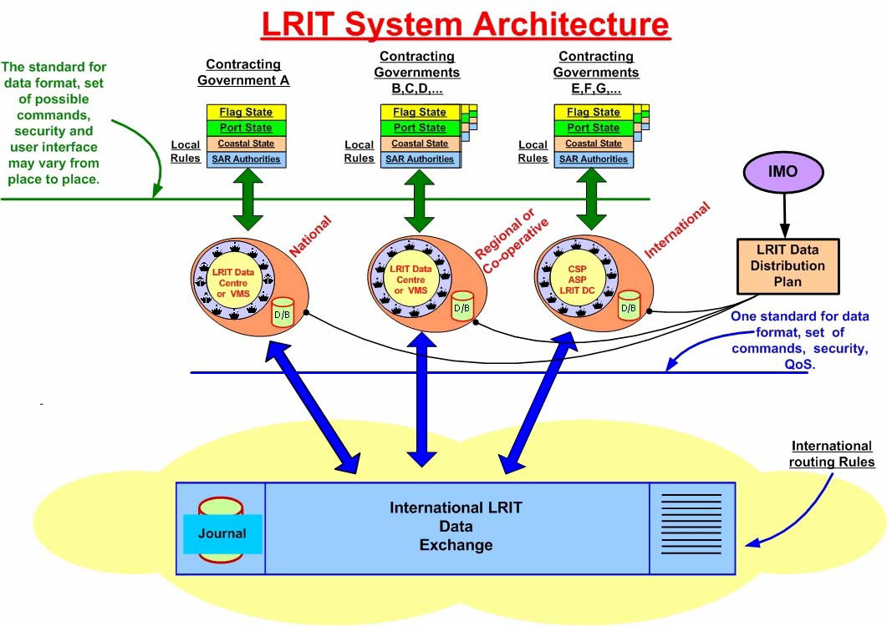
2.2 System Functions
2.2.1 The general functionality of the International LRIT Data Centre is addressed in MSC.210(81).
2.3 LRIT Information Reporting
2.3.1 Data Requirements
Shipborne units will transmit position, identification and time and be capable of automatically and without human intervention on board the ship transmitting the ship’s LRIT information at 6-hour intervals to an LRIT Data Centre; In addition to the provisions specified in paragraph 4.1 above, the shipborne equipment shall provide the functionality specified in table 1.
2.3.2 System Capacity
The International LRIT Data Centre shall be capable of processing 50,000 SOLAS Class ships. Based on the requirement for ships to transmit LRIT information four times per day, this results in 50,000 x 4 reports per day = 200,00 reports per day.
System capacity shall be sufficient to perform archival and retrieval of LRIT information as specified in MSC Res. 210 (81) para. 7.1, for a period of at least one year.

TABLE 1
DATA TO BE TRANSMITTED FROM THE SHIPBORNE EQUIPMENT

Parameter | Comments
Shipborne equipment Identifier | The identifier used by the shipborne equipment.
 | The GNSS position (latitude and longitude) of the ship (based on the WGS84 datum).
 | Position: The equipment should be capable of transmitting the GNSS position (latitude and longitude) of the ship (based on WGS84 datum) as prescribed by regulation V/19-1, without human interaction on board the ship.
Positional data | On-demand⁽¹⁾position reports: The equipment should be capable of responding to a request to transmit LRIT information on demand without human interaction onboard the ship, irrespective of where the ship is located.
 | Pre-scheduled⁽²⁾position reports: The equipment should be capable of being remotely configured to transmit LRIT information at intervals ranging from a minimum of 15 minutes to periods of 6 hours to the LRIT Data Centre, irrespective of where the ship is located and without human interaction on board the ship.
Time Stamp 1 | The date and time⁽³⁾associated with the GNSS position. The equipment should be capable of transmitting the time⁽³⁾associated with the GNSS position with each transmission of LRIT information.
Notes: | (1) On-demand position reports means transmission of LRIT information as a result of either receipt of polling command or of remote configuration of the equipment so as to transmit at interval other than the preset ones.
 | (2) Pre-scheduled position reports means transmission of LRIT information at the preset transmit intervals.
 | (3) All times should be indicated as Universal Co-ordinated Time (UTC).

3 System Architecture / High Level Design
This section describes the high-level overview of the system architecture including a data flow diagram.
International LRIT Data Centre Block Diagram
3.1 Top Level Block Diagram Description
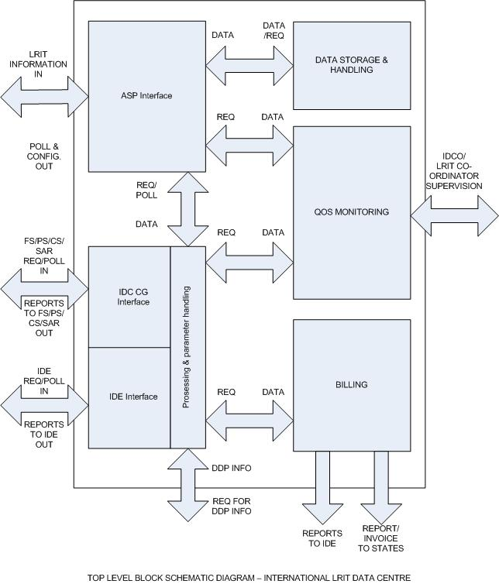

4 Functional Requirements
The International LRIT Data Centre shall receive, store and disseminate LRIT information. The International LRIT Data Centre shall perform the following requirements.
General requirements
The International LRIT Data Centre shall verify communications and provide for data security using methods such as Authorization; Authentication; Confidentiality; Integrity and as specified in the LRIT Communications Specification.
Maintain a record of the ships which transmit LRIT information to the centre including name of ship, IMO Ship identification number, Call Sign and Maritime Mobile Service Identity (MMSI), current reporting intervals (as requested by the various Contracting Governments);
Maintain a current list of Ships no longer transmitting data to the IDC (eg. Change of flag, taken out of service). Amend the information above upon the transfer of a Flag of a Ship and to include the following:
.1 The effective date and time (UTC) of transfer; and
.2 The State whose the flag the ship was formally entitled to fly, if known.

ensure using appropriate hardware and software, that LRIT information is backed-up at regular intervals, stored at suitable off-site location(s) and available as soon as possible in the event of disruption to ensure continuity of service;
ASP Interface: Processes the incoming LRIT information from the ASP and routes polling and standing order requests to the ASP.
Receive LRIT information from ships instructed by their Administrations to transmit the LRIT information to the centre;
add the appropriate data identified in table 2 to each transmission of LRIT information collect by the centre
execute requests received from LRIT Data Users for polling of LRIT information or for change(s) in the interval(s) of transmission of LRIT information by a ship or a group of ships transmitting the information to the centre;
LRIT Information storage and handling
archive LRIT information from ships which transmit the information to the centre, for at least one year and until such time as the Committee reviews and accepts the annual report of the audit of its performance by the LRIT Co-ordinator.
Perform database storage and retrieval in accordance with the following schedule:
.1 for LRIT information archived within the last 4 days, send the LRIT information within 30 minutes of receiving a request;
.2 for LRIT information archived between 4 and 30 days previously, send the LRIT information within 1 hour of receiving a request;
.3 for LRIT information archived more than 30 days previously, send the LRIT information within 5 days of receiving a request;
IDC Contracting government interface: Processes polling, requests, and standing orders directly from Contracting Governments whose ships are reporting to the IDC.
use a secure authentication method with LRIT Data Users;
Perform authentication based on the LRIT Data Distribution Plan. Establish and continuously maintain systems which ensure, at all times, that LRIT Data Users are only provided with the LRIT information they are entitled to receive as specified in regulation V/19-1;
Upon request disseminate to LRIT Data Users the LRIT information they are entitled to receive in accordance with the agreed arrangements and notify the LRIT Data User and the Administration when a particular ship stops transmitting LRIT information. Additionally, prohibit the dissemination of LRIT information to Contracting Governments in accordance with Regulation V/19-1.9.1 and as provided in the LRIT Data Distribution Plan.
Provide to Search and rescue services (SAR services), LRIT information transmitted by all ships located within the geographic area specified by the SAR service requesting the information so as to permit the rapid identification of ships which may be called upon to provide assistance in relation to the search and rescue of persons in distress at sea. The LRIT information shall be provided irrespective of the location of the geographic area and shall be provided even if the geographic area is outside the search and rescue region associated with the SAR service requesting the information (regulation V/19-1.12 refers).
IDE Interface: Processes polling, requests, and standing orders directly from Contracting Governments using other data centres.
The International LRIT Data Centre shall respond to all queries from all data centres through the data exchange.
Communicate with LRIT Data Centres through the International LRIT Data Exchange in accordance with Technical Specifications for the International LRIT Data Exchange and Technical Specifications for Communications within the LRIT System Network;
Perform authentication based on the LRIT Data Distribution Plan. establish and continuously maintain systems which ensure, at all times, that LRIT Data Users are only provided with the LRIT information they are entitled to receive as specified in regulation V/19-1;
When requested, provide LRIT information transmitted by ships other than those which transmit the information to the centre, LRIT information from other LRIT Data Centres through the International LRIT Data Exchange;
Make available, when requested to provide LRIT information transmitted by ships other than those which transmit the information to the centre, LRIT information transmitted to the centre to other LRIT Data Centres through the International LRIT Data Exchange;
Relay, when required, requests received from LRIT Data Users through the International LRIT Data Exchange to the other LRIT Data Centres for polling of LRIT information or for change(s) in the interval(s) of transmission of LRIT information by a ship or a group of ships not transmitting the information to the centre;
Upon request disseminate to LRIT Data Users the LRIT information they are entitled to receive in accordance with the agreed arrangements and notify the LRIT Data User and the Administration when a particular ship stops transmitting LRIT information. Additionally, prohibit the dissemination of LRIT information to Contracting Governments in accordance with Regulation V/19-1.9.1 and as provided in the LRIT Data Distribution Plan.
Provide to Search and rescue services (SAR services), LRIT information transmitted by all ships located within the geographic area specified by the SAR service requesting the information so as to permit the rapid identification of ships which may be called upon to provide assistance in relation to the search and rescue of persons in distress at sea. The LRIT information shall be provided irrespective of the location of the geographic area and shall be provided even if the geographic area is outside the search and rescue region associated with the SAR service requesting the information (regulation V/19-1.12 refers).
Quality of Service Monitoring: Monitors the ASP, IDC, and IDE interfaces. Responds to quality-related requests from IDC Operator and LRIT Coordinator.
Provide to the LRIT Coordinator the required level of access to management, charging, technical and operational data to enable the satisfactory completion of an audit of the IDC performance
the archived LRIT information shall provide a complete record of the activities of the centre between two consecutive annual audits of its performance;
Provide sufficient information to an IDC operator for daily operation at required levels of reliability, maintenance and availability.
The IDC shall be able to measure Quality of Service as defined in MSC.210(81)

Billing handling
Monitors the ASP, IDC, and IDE interfaces for billing transactions and related data. Relevant data are processed. Generates reports to IDE and invoices to Contracting Governments.
[To be specified in detail when the billing concept of the LRIT System is agreed upon.]

International LRIT Data Centre system performance
The IDC shall process and handle any input within 60 seconds of its receipt and give the appropriate output. This output may be a direct response to the request or it may be a request for information from another part of the LRIT system. This shall include validation of requests in accordance with the Data Distribution Plan, if necessary.
The IDC shall be capable of receiving and storing at least 5 reports per second.
Availability & Reliability
The IDC shall provide data to the LRIT system 24 hours per day 7 days per week with better than 99.9% availability measured over a year and better than 95% availability per day.
Maintainability

The equipment should be so designed that the main units can be replaced readily, without elaborate recalibration or readjustment.

Equipment should be so constructed and installed that it is readily accessible for inspection and maintenance purposes.

4.1 IDC External Interfaces
Application Service Providers:
The International LRIT Data Centre shall interact with Communications Service Providers through a communications protocol provided by an Application Services Provider to enable the following minimum functionality:
- remote integration of the shipborne equipment into the International LRIT Data Centre;
- automatic configuration of transmission of LRIT information;
- automatic modification of the interval of transmission of LRIT information
- automatic suspension of transmission of LRIT information; on demand transmission of LRIT information; and
- automatic recovery and management of transmission of LRIT information
- provide an integrated transaction management system for the monitoring of LRIT information throughput and routeing; and
- ensure that LRIT information is collected, stored and routed in a reliable and secure manner.

The International LRIT Data Centre shall be capable of receiving and processing the data in Table 2 added by an ASP (where used) to each transmission of LRIT information:
TABLE 2
DATA TO BE ADDED BY AN APPLICATION SERVICE PROVIDER
AND AT THE LRIT DATA CENTRE
Parameters |  | Comments
Ship Identity(1) |  | The IMO ship identification number⁽¹⁾and MMSI for the ship.
Time Stamp 2 |  | The date and time⁽²⁾the position report is received by the ASP (if used).
Time Stamp 3 |  | The date and time⁽²⁾the position report is forwarded from the ASP (if used) to the appropriate LRIT Data Centre.
LRIT Data Centre Identifier |  | The identity of the LRIT Data Centre to be clearly indicated by a Unique Identifier.
Time Stamp 4 |  | The date and time⁽²⁾the position report is received by the LRIT Data Centre.
Time Stamp 5 |  | The date and time⁽²⁾the position report is forwarded from the LRIT Data Centre to an LRIT Data User.
 | Notes: | (1) See regulation XI-1/3 and Assembly resolution A.600(15) on IMO ship identification number scheme.
 |  | (2) All times should be indicated as Universal Co-ordinated Time (UTC).

Contracting Governments
Under the provisions of regulations V/19.1 (attached as Annex “ “ herein), the International Data Centre shall provide requested LRIT information to Contracting Governments in the LRIT Data Distribution Plan if:
- it is entitled to under the provisions of regulation V/19-1;
- the LRIT data centre shall verify the validity of all requests for information against the criteria established in the regulation V/19-1. If so decided, the Contracting Government may give the International LRIT Data Centre a standing order regarding the criteria for receiving LRIT information.
- The Data Centre shall compare requests for LRIT information against the criteria in the Data Distribution Plan and any standing orders which it has received;
International LRIT Data Exchange

The International LRIT Data Centre shall interface to the International Data Exchange.
LRIT Data Distribution Plan
The IDC shall interface with the DDP server and receive updates to the plan automatically. Request for a copy of the most recent DDP can be initiated by the IDC when required.
LRIT Co-ordinator
As required by the LRIT Co-ordinator, the International LRIT Data Centre shall:
.1 Grant access to the LRIT Co-ordinator for management, charging, technical and operational data as applicable by the IDC;
.2 send compiled IDC statistics, error reports, etc. to the LRIT Co-ordinator .

  - Proposal for further specification of the IDC

The detailed description of the International LRIT Data Centre can include a set of SDL (Specification and Description Language) diagrams or other suitable Event-Based Architecture Description Language intended for complex software systems.
