J paper on
Draft Guidance on
Setting Up and Maintaining the LRIT Data Distribution Plan

Prepared by: Ad Hoc Engineering Working Group (CCG edited)

Table of Contents
1 General Provisions 1
1.1 Scope and Background 1
1.1.1 Scope 1
1.1.2 Background 1
1.2 General Description of the System and Definitions 1
1.2.1 LRIT System Description 1
1.2.2 LRIT System Operation 1
1.2.3 Definitions 3
1.2.4 Acronyms Used Within This Document 4
2 The Data Distribution Plan 4
3 Guidance on the Data Distribution Plan with Respect to Accountability 4
4 Guidance with respect to Data Distribution Plan Content 5
5 Guidance on the Format of the Data Distribution Plan 6
6 Guidance on Populating the Data Distribution Plan: 6
7 Data Distribution Plan Performance Requirements 7
8 Data Distribution Plan Dissemination to other Elements of the International LRIT System 7
9 Links to the Data Distribution Plan 8

Draft Guidance on Setting up and Maintaining the LRIT Data Distribution Plan
- General Provisions
  - Scope and Background
    - Scope
      - The intent of this document is to provide draft guidance on setting up and maintaining the Data Distribution Plan within the international Long-Range Identification and Tracking (LRIT) system as stated in the terms of reference of resolution MSC.210(81).
      - This document has been prepared by the Ad Hoc Working Group on Engineering Aspects of Long-Range Identification and Tracking of Ships.
      - In preparing the document, the Ad Hoc Working Group has taken into account the provisions of SOLAS regulation V/19-1 and resolution MSC.210(81), “Performance Standards and Functional Requirements for the Long Range Identification and Tracking of Ships.”
    - Background
      - The Maritime Safety Committee, at its eighty-first session in May 2006, adopted amendments to chapter V of the SOLAS convention in relation of LRIT. These amendments will come into force on 1 January 2008 provided that acceptance criteria have been fulfilled by 1 July 2007.
      - The LRIT system provides for the global identification and tracking of ships.
      - In operating the LRIT system, recognition shall be given to international conventions, agreements, rules or standards that provide for the protection of navigational information.
  - General Description of the System and Definitions
    - LRIT System Description
      - As described in resolution MSC.210(81), sub-section 1.2, the LRIT system consists of the following components:
        - the shipborne LRIT information transmitting equipment;
        - the Communication Service Provider(s);
        - the Application Service Provider(s);
        - the LRIT Data Centre(s), including any related Vessel Monitoring System(s);
        - the LRIT Data Distribution Plan;
        - the International LRIT Data Exchange; and
        - LRIT Data Users.
      - As described in resolution MSC.210(81), sub-section 1.2, certain aspects of the performance of the LRIT system are reviewed or audited by an LRIT Co-ordinator acting on behalf of all Contracting Governments
    - LRIT System Operation
      - Sub-sections 1.1.1.9 to 1.1.1.19 provide a high-level overview of the LRIT system architecture. The LRIT system Performance standards, resolution MSC.210(81), provide further details on the functions associated with each component of the system.
      - Tracking of any applicable ship begins with LRIT positional data being transmitted from the shipborne equipment. The LRIT information transmitted includes the ship’s GNSS position (based on the WGS 84 datum), time and identification, as described in resolution MSC.210(81), Table 1.
      - The Communication Service Provider (CSP) provides the communication infrastructure and services that are necessary for establishing a communication path between the ship and the Application Service Provider (ASP). The LRIT information transmitted from the ship will travel across the communication path set up by the CSP to the ASP.
      - The ASP, after receiving the LRIT information from the ship, will add additional information to the LRIT message and pass along the expanded message to its associated LRIT Data Centre. Functionality required for the programming and communicating of commands to the shipborne equipment is provided by the ASP.
      - The LRIT data, along with all the parameters added by the various LRIT components, is described in the messaging section of the “Draft Technical Specifications for Communication within the LRIT System.”
      - LRIT Data Centres will store all incoming LRIT information from ships instructed by their Administrations to transmit LRIT information to that Data Centre. LRIT Data Centres will disseminate LRIT information to LRIT Data Users according to the Data Distribution Plan (DDP).
      - The LRIT Data Distribution Plan will contain the information required by the Data Centres for determining how LRIT information will be distributed to the various Contracting Governments. The DDP will contain information such as standing orders from Contracting Governments and geographical polygons relating to Contracting Governments’ coastal waters and ports and port facilities.
      - Data Centres will process all LRIT messages to and from the International LRIT Data Exchange (IDE). The IDE will process all LRIT messages between LRIT Data Centres. The IDE will route the message to the appropriate Data Centre based upon the information contained within the DDP. The IDE will neither process nor store the positional data contained within LRIT messages.
      - LRIT Data Users may be entitled to receive or request LRIT information in their capacity as a flag State, port State, coastal State or Search and Rescue (SAR) service.
      - The LRIT Co-ordinator assists in the establishment of the international components of the LRIT system, performs administrative functions, and reviews and audits certain components of the LRIT system.
      - Figure 1 provides an illustration of the LRIT system architecture.
Figure 1
Typical LRIT System Architecture

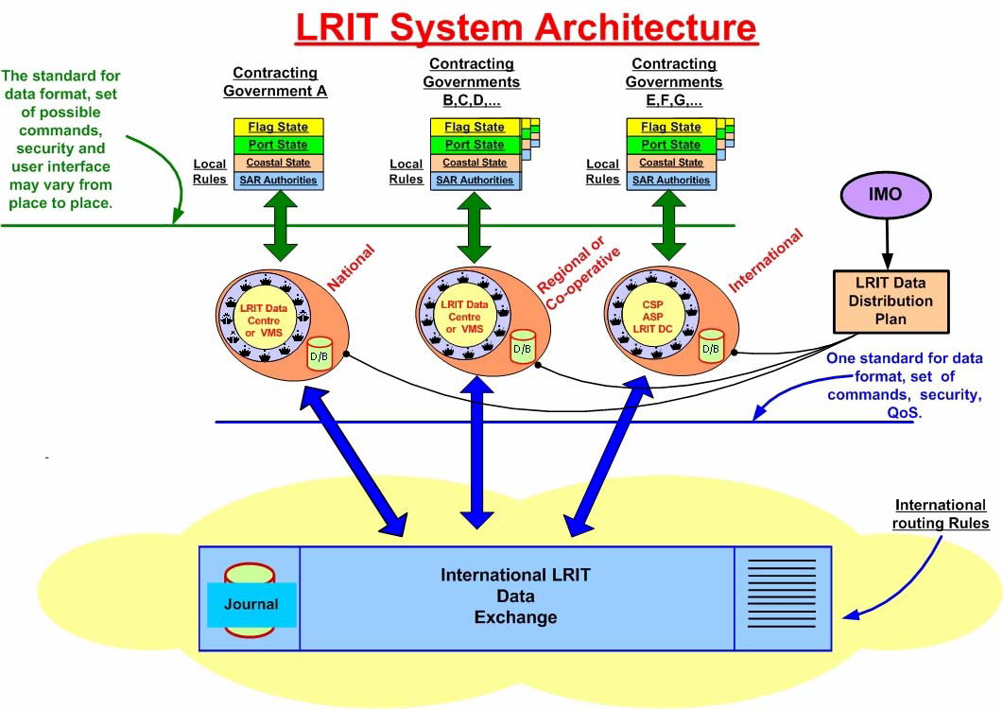
    - Definitions
      - Unless expressly provided otherwise:
        - Convention means the International Convention for the Safety of Life at Sea, 1974, as amended.
        - Regulation means a regulation of the Convention.
        - Chapter means a chapter of the Convention.
        - LRIT Data User means a Contracting Government or a Search and rescue service that opts to receive the LRIT information it is entitled to.
        - Committee means the Maritime Safety Committee.
        - High-speed craft means a craft as defined in regulation X/1.3.
        - Mobile offshore drilling unit means a mobile offshore drilling unit as defined in regulation XI-2/1.1.5.
        - Organization means the International Maritime Organization.
        - Vessel Monitoring System means a system established by a Contracting Government or a group of Contracting Governments to monitor the movements of the ships entitled to fly its or their flag. A Vessel Monitoring System may also collect from the ships information specified by the Contracting Government(s) that has established it.
        - LRIT information means the information specified in SOLAS regulation V/19-1.5.
        - IDC operator means the individual responsible for the daily operation and maintenance of the International LRIT Data Centre.
      - The term “ship,” when used in the present Performance standards and functional requirements for long-range identification and tracking of ships (the Performance standards), includes mobile offshore drilling units and high-speed craft as specified in SOLAS regulation V/19-1.4.1 and means a ship that is required to transmit LRIT information.
      - Terms not otherwise defined should have the same meaning as the meaning attributed to them in the Convention.
    - Acronyms Used Within This Document
      - The acronyms that appear within this document shall have the meanings assigned to them in this Article:
        - ASP Application Service Provider
        - CSP Communication Service Provider
        - DC LRIT Data Centre
        - DDP LRIT Data Distribution Plan
        - IDC International LRIT Data Centre
        - IDE International LRIT Data Exchange
        - LES Land Earth Station
        - MMSI Maritime Mobile Service Identity
        - RFP Request for Proposal
        - SAR Search and Rescue
        - SAR SURPIC Search and Rescue Surface Picture
        - SOLAS International Convention for the Safety of Life at Sea
        - SSL Secure Sockets Layer
        - VPN Virtual Private Network
        - VMS Ship Management System
- The Data Distribution Plan
- The Data Distribution Plan will reside and be managed by a web server (such as GISIS).
- The LRIT Data Distribution Plan contains the critical tombstone information, the different polygons, distances and standing orders that are involved with flag State, port State, coastal State, and SAR access to the LRIT information.
- The tombstone information resident in the Data Distribution Plan allows the entire international LRIT system to function. Without it, the individual elements of the system would be unable to communicate with each other and the Data Centres would not know what information they were allowed to transfer through the International LRIT Data Exchange (IDE) to other Data Centres based on the various access schemes.
- Guidance on the Data Distribution Plan with Respect to Accountability
- As stated in section 11.1 of the Performance standards (resolution MSC.210(81)), “The Organization should establish and maintain the LRIT Data Distribution Plan.” Thus the IMO Secretariat will hold the Data Distribution Plan.
- However, once the LRIT Co-ordinator has been appointed and the two international components of the LRIT System have been established — namely the International LRIT Data Centre and the International LRIT Data Exchange — it is recommended that the Secretariat and the Organization re-evaluate the location and management of the Data Distribution Plan. Since the Data Distribution Plan will hold the tombstone information, there is value in co-locating it with the IDE.
- Since Contracting Governments will be required to enter the pertinent information regarding LRIT into the Data Distribution Plan, then Contracting Governments are accountable for the validity of the information within the Data Distribution Plan. If, for example, a Contracting Government does not give a standing order with respect to coastal State, then that Government will not receive any information pursuant to coastal State tracking.
- Guidance with respect to Data Distribution Plan Content
- Section 11.2 of the Performance standards lists the content of the Data Distribution Plan. Each paragraph is repeated below with proposed guidance given for each paragraph. General guidance is given at the end of Part 4 of this document.
- Section 11.2.1, “a list of Contracting Governments and SAR services entitled to receive LRIT information, and their points of contact.”
        - This information must be added by the IMO Secretariat.
        - Section 11.2.2, “information on the boundaries of geographic areas within which each Contracting Government is entitled to receive LRIT information about ships in the area.”
        - This information must be added by the IMO Secretariat, and will be used to verify a Contracting Government’s standing orders.
        - Section 11.2.3, “information on any standing orders given by a Contracting Government pursuant to paragraphs 16.1.2, .16.1.3 and/or 16.1.4.”
        - Paragraph 16.1.2 contains the standing orders for flag State tracking. While the Administration’s Data Centre requires this information, it is not useful for the Data Distribution Plan. However, since it is thus referenced in the Performance Standard, the Data Distribution Plan must be capable of accepting this data from a Contracting Government.
        - Paragraph 16.1.3 contains the standing order for port State tracking. If the distance from a port is used, then the information from section 11.2.6 must be used in conjunction with this standing order. Although this is a standing order, a Notice of Arrival (NOA) must still be transmitted by the Contracting Government through its Data Centre to the destination Data Centre. The information contained in the standing order should include, but is not limited to, the following: ship name, IMO ship identification number, vessel’s flag state and the distance from the Contracting Government’s port.
        - Paragraph 16.1.4 contains the standing order for coastal State tracking. The Contracting Government should be able to enter either the distance from its coast or a polygon that defines the standing order. The Data Distribution Plan should compare the resulting polygon with that defined in Sub-section 11.2.2 of the Performance standards to ensure it is valid. The Contracting Government may also optionally submit standing orders that contain criteria based upon the desire of that Contracting Government to track — or not track — vessels of a particular flag State.
        - Section 11.2.4, “information supplied by Administrations pursuant to the provisions of regulation V/19-1.8.1.4”.
        - The Administration’s Data Centre will use this information to modify the coastal State tracking output function.
        - Section 11.2.5, “information supplied by Administrations pursuant to the provisions of regulation V/19-1.9.2.”
        - The Administration’s Data Centre will use this information to modify the coastal State tracking output function.
        - Section 11.2.6, “a list of ports and port facilities together with the associated geographic coordinates (based on WGS 84 datum) located within the territory of each Contracting Government.”
        - This information will be used if a Contracting Government is using the distance from a port or port facility to start port State tracking.
        - Section 11.2.8, “a list of the National, Regional, Co-operative and International LRIT Data Centre(s) and their points of contact.”
        - The Internet address of each Data Centre should also be added. This will allow all components of the International LRIT system to communicate with each other.
        - Section 11.2.9, “a record indicating which LRIT DC is collecting and archiving LRIT information for each of the Contracting Governments.”
        - This information is required in order to map a ship via its flag with a Data Centre.
        - All of this tombstone information should be available to all Contracting Governments and all LRIT entities.
        - There is no 11.2.7 in the performance standard. The section should be re-numbered.
- Guidance on the Format of the Data Distribution Plan
- The Data Distribution Plan should use a standard data exchange format, such as XML.
- The Data Distribution Plan should use a data format that is concise and contains the necessary information at the lowest byte size possible.
- Guidance on Populating the Data Distribution Plan:
- The Performance standards do not indicate how the information that Contracting Governments provide to the Organization are input to the Data Distribution Plan. If Contracting Governments are responsible for providing this information to the Organization in accordance with Regulation section 1.8.2, and the Organization is responsible for establishing and maintaining the Data Distribution Plan under paragraph 11.1 of the Performance standards as noted previously, then it is implicit that the information to populate the Data Distribution Plan travels from a Contracting Government to the Organization into the Data Distribution Plan. This applies for both the initial Data Distribution Plan setup and for updating the Data Distribution Plan in-service.
- The uploading of information from each Contracting Government to the Organization (and into the Data Distribution Plan) should happen automatically without human intervention by the IMO Secretariat.
- The Data Distribution Plan must be available to authorized LRIT entities via a web server held by the IMO Secretariat.
- The Data Distribution Plan must have the capability for Contracting Governments to enter and update the Data Distribution Plan information.
- The Data Distribution Plan server must keep an archive of the previous versions of the Data Distribution Plan. This archive should be used by the LRIT Co-ordinator for auditing purposes.
- The Data Distribution Plan server should automatically verify the format and values for each entry that a Contracting Government makes into the Data Distribution Plan.
- The requirements for communications security are included in the “Draft Technical Specifications for Communication in the LRIT System.”
- Data Distribution Plan Performance Requirements
- Due to the critical nature of the Data Distribution Plan’s information, it must be available 24 hours a day, 7 days a week with an availability of 99.9% over the year and 95% over a day. The availability targets should be reduced if they make the cost of the Data Distribution Plan exorbitant.
- Data Distribution Plan Dissemination to other Elements of the International LRIT System
- The LRIT System Diagram shows that the Data Distribution Plan is transferred directly to the other elements of the LRIT system, therefore there is no other option for disseminating the Data Distribution Plan.
- The Data Distribution Plan server must automatically push the Data Distribution Plan to all Data Centres and the International LRIT Data Exchange whenever the Data Distribution Plan is updated.
        - The Data Distribution Plan must keep a log that the information was successfully received by each Data Centre and the International LRIT Data Exchange. This information will be used by the LRIT Co-ordinator for auditing purposes.
        - The Data Distribution Plan will be pushed to the Data Centres and the International LRIT Data Exchange by the use of the Data Distribution Plan Update message (message type 9) as described in “Draft Technical Specifications for Communication in the LRIT System.”.
        - The Data Distribution Plan server must allow any authorized LRIT entity to request a copy of the Data Distribution Plan at any time by using the Data Distribution Plan Request message.
        - If the size of the Data Distribution Plan file is in the range of 1 to 5 MB, then the file should be distributed in its entirety to all of the LRIT entities. However, if the size of the file is much greater than this, then it should be disseminated as changes to the file to save on communications bandwidth and time. As an example the Data Distribution Plan can be segmented by Contracting Governments so that when changes are made the file for each Contracting Government that has been changed will be pushed out as opposed to the entire Data Distribution Plan.
- Links to the Data Distribution Plan
- The system architecture figure in the Performance Standards does not have an arrow linking the Data Distribution Plan to the International LRIT Data Exchange, therefore that component of the system architecture figure is open to interpretation:
        - One possible interpretation might be that all communications with the Data Distribution Plan are limited only to communications with Data Centres. This would not allow for the requirement under the Performance standards, 10.3.13, for the International LRIT Data Exchange to “have continuous access to (the) current LRIT Data Distribution Plan.”
        - Another possible interpretation is that figure reflects the concept that the intelligence (content) of the Data Distribution Plan is shared only with Data Centres, and not with the International LRIT Data Exchange, while still allowing for the routing of the Data Distribution Plan through the International LRIT Data Exchange.
        - The technical specifications as currently drafted are based on the premise that the Data Distribution Plan is not to be routed through the International LRIT Data Exchange, but that the International LRIT Data Exchange, like all Data Centres, must have continuous access to the current Data Distribution Plan. Therefore, the diagram should be updated to show a connection from the Data Distribution Plan to the following users of the Data Distribution Plan:
.1 Data Centres;
.2 the International LRIT Data Centre;
.3 the International LRIT Data Exchange;
.4 Contracting Governments;
.5 the LRIT Co-ordinator; and
.6 the IMO Secretariat.

- 16.1.2 refers to provisions of regulation V/19-1.8.1.1 (flag State); - 16.1.3 refers to provisions of regulation V/19-1.8.1.2 (port State);and - 16.1.4 refers to provisions of regulation V/19-1.8.1.3 (coastal State).

