Draft Protocols for the
Development Testing
of the LRIT System
and for Testing the Integration
New LRIT Data Centres
into the System

Prepared by: Ad Hoc Engineering Working Group February 2007, amended by the sub group on testing.
Date of issue of this Draft: June 22, 2007

Table of Contents
1 General Provisions 1
1.1 Scope and Background 1
1.1.1 Scope 1
1.1.2 Background 1
1.2 General Description of the System and Definitions 1
1.2.1 LRIT System Description 1
1.2.2 LRIT System Operation 2
1.2.3 Definitions 3
1.2.4 Acronyms Used Within This Document 4
2 Testing Protocol 4
2.1 General 4
2.2 User Test Cases 5
3 Initial Developmental Testing 6
3.1 General 6
3.2 International LRIT Data Exchange Development Testing 6
3.2.5 Laboratory Testing Using a Data Centre Simulator 7
3.2.6 Parallel Operational Test 7
3.2.7 Operational Testing 8
3.3 International LRIT Data Centre Development Testing 8
3.4 Data Distribution Plan Development Testing 9
4 Commissioning Test Process 10
4.1 General 10
4.2 Successful Completion of Test 10
5 Integration and Modification Test Process 10
5.1 General 10
5.2 Integration Test Process for New Components 11
5.2.2 Integration of New Data Centres 11
5.3 Modification of LRIT System Components 11
6 Procedure for reporting on Testing to MSC 11
6.1 General 11
6.2 Liaison Process for Initial Developmental Testing 12
6.3 Liaison process for integration and modification testing 13
6.4 Liaison and update process for LRIT related documentation 13

DRAFT Protocols for the Development Testing of the LRIT System and for Testing the Integration New LRIT Data Centres in the system
- General Provisions
  - Scope and Background
    - Scope
      - The intent of this document is to provide draft protocols for the development testing of the international Long-Range Identification and Tracking (LRIT) system and for testing the integration of new LRIT Data Centres into the system.
      - This document has been prepared by the Ad Hoc Working Group on Engineering Aspects of Long-Range Identification and Tracking of Ships.
      - In preparing the document, the Ad Hoc Working Group has taken into account the provisions of SOLAS regulation V/19-1 and resolution MSC.210(81), “Performance Standards and Functional Requirements for the Long Range Identification and Tracking of Ships.”
      - The document describes the testing protocol to ensure the successful implementation of the International LRIT system and the sustainability of the system.
      - Detailed tests shall be identified in the relevant developmental contract and in consultation with the LRIT Coordinator.
    - Background
      - The Maritime Safety Committee, at its eighty-first session in May 2006, adopted amendments to chapter V of the SOLAS convention in relation of LRIT. These amendments will enter into force on 1 January 2008 provided that acceptance criteria have been fulfilled by 1 July 2007.
      - The LRIT system provides for the global identification and tracking of ships.
      - In operating the LRIT system, recognition shall be given to international conventions, agreements, rules or standards that provide for the protection of navigational information.
      - The draft Protocols for the Development Testing of the LRIT System and for Testing the Integration into the System of New LRIT Data Centres for the international LRIT system as outlined in this document will be established and recognised by the Committee.
  - General Description of the System and Definitions
    - LRIT System Description
      - As described in resolution MSC.210(81), sub-section 1.2, the LRIT system consists of the following components:
        - shipborne LRIT information transmitting equipment;
        - Communication Service Provider(s);
        - Application Service Provider(s);
        - LRIT Data Centre(s), including any related Vessel Monitoring System(s);
        - LRIT Data Distribution Plan;
        - International LRIT Data Exchange; and
        - LRIT Data Users.
      - As described in resolution MSC.210(81), sub-section 1.2, certain aspects of the performance of the LRIT system are reviewed or audited by an LRIT Co-ordinator acting on behalf of all Contracting Governments.
    - LRIT System Operation
      - Subsections 1.1.1.12 to 1.1.1.22 provide a high-level overview of the LRIT system architecture. The LRIT system performance standards, resolution MSC.210(81), provide further details on the functions associated with each component of the system.
      - Tracking of any applicable ship begins with LRIT positional data being transmitted from the shipborne equipment. The LRIT information transmitted includes the ship’s GNSS position (based on the WGS 84 datum), time and identification, as described in resolution MSC.210(81), Table 1.
      - The Communication Service Provider (CSP) provides the communication infrastructure and services that are necessary for establishing a communication path between the ship and the Application Service Provider (ASP). The LRIT information transmitted from the ship will travel across the communication path set up by the CSP to the ASP.
      - The ASP, after receiving the LRIT information from the ship, will add additional information to the LRIT message and pass along the expanded message to its associated LRIT Data Centre. Functionality required for the programming and communicating of commands to the shipborne equipment is provided by the ASP.
      - The LRIT data, along with all the parameters added by the various LRIT components, is described in the messaging section of the “Draft Technical Specifications for Communication within the LRIT System.”
      - LRIT Data Centres will store all incoming LRIT information from ships instructed by their Administrations to transmit LRIT information to that Data Centre. LRIT Data Centres will disseminate LRIT information to LRIT Data Users according to the Data Distribution Plan (DDP).
      - The LRIT Data Distribution Plan will contain the information required by the Data Centres for determining how LRIT information will be distributed to the various Contracting Governments. The DDP will contain information such as standing orders from Contracting Governments and geographical polygons relating to Contracting Governments’ coastal waters and ports and port facilities.
      - The Data Centres will process all LRIT messages to and from the International LRIT Data Exchange (IDE). The IDE will process all LRIT messages between LRIT Data Centres. The IDE will route the message to the appropriate Data Centre based upon the information contained within the DDP. The IDE will neither process nor store the positional data contained within LRIT messages.
      - LRIT Data Users may be entitled to receive or request LRIT information in their capacity as a flag State, port State, coastal State or Search and Rescue (SAR) service.
      - The LRIT Co-ordinator assists in the establishment of the international components of the LRIT system, performs administrative functions, and reviews and audits certain components of the LRIT system.
      - Figure 1 provides an illustration of the LRIT system architecture. The various components and interfaces shall be tested as follows:
        - functionality of the International LRIT Data Exchange and all of its interfaces;
        - functionality of the International LRIT Data Centre and all of its interfaces;
        - functionality of the Data Distribution Plan and all of its interfaces;
        - interface to all National and Regional / Co-operative Data Centres; and
        - End-to-end testing of system (as indicated in Figure 2)

Figure 1
Typical LRIT System Architecture

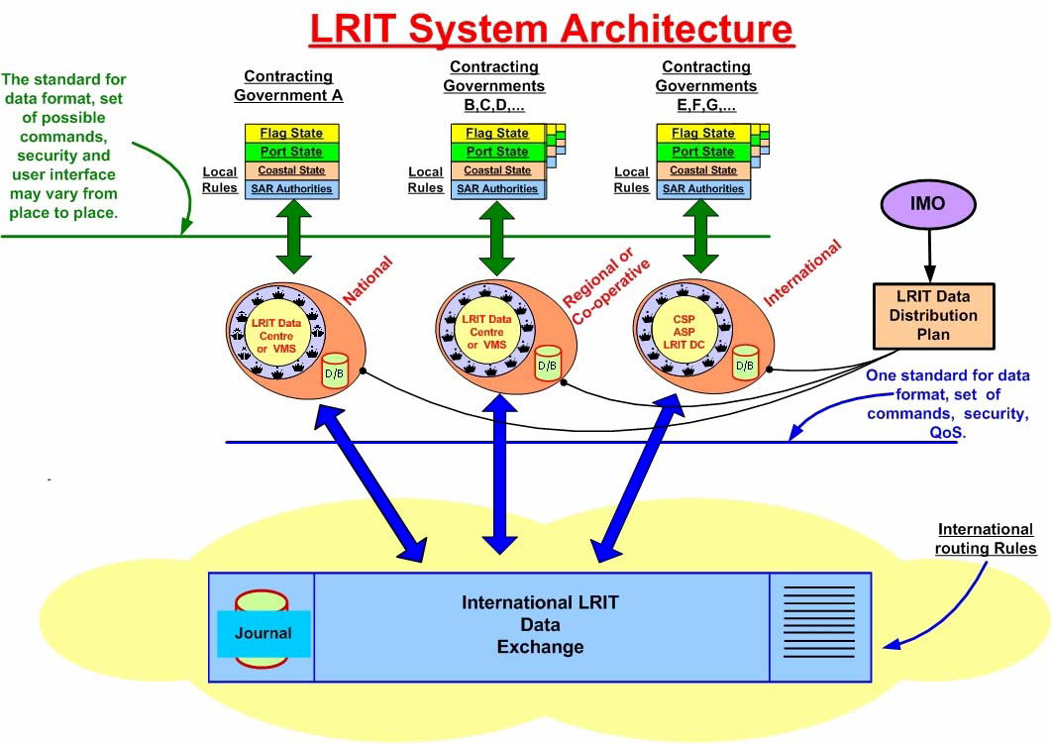
Figure 2
Elements of LRIT System included in this testing protocol document
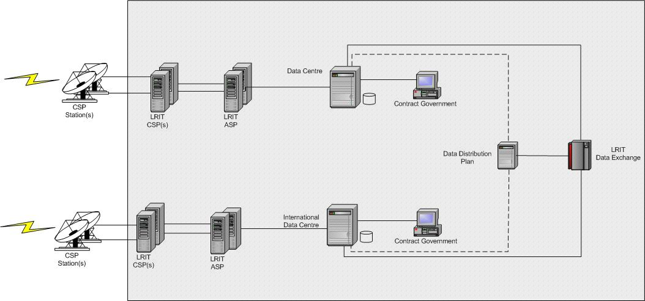
    - Definitions
      - Unless expressly provided otherwise:
        - Convention means the International Convention for the Safety of Life at Sea, 1974, as amended.
        - Regulation means a regulation of the Convention.
        - Chapter means a chapter of the Convention.
        - LRIT Data User means a Contracting Government or a Search and rescue service that opts to receive the LRIT information it is entitled to.
        - Committee means the Maritime Safety Committee.
        - High-speed craft means a craft as defined in regulation X/1.3.
        - Mobile offshore drilling unit means a mobile offshore drilling unit as defined in regulation XI-2/1.1.5.
        - Organization means the International Maritime Organization.
        - Vessel Monitoring System means a system established by a Contracting Government or a group of Contracting Governments to monitor the movements of the ships entitled to fly its or their flag. A Vessel Monitoring System may also collect from the ships information specified by the Contracting Government(s) that has established it.
        - LRIT information means the information specified in SOLAS regulation V/19-1.5.
        - IDC operator means the individual responsible for the daily operation and maintenance of the International LRIT Data Centre.
        - International Routing Rules – a list of all data centres with their associated IP addresses as identified in the DDP
        - Ship - when used in the present Performance standards and functional requirements for long-range identification and tracking of ships, includes mobile offshore drilling units and high-speed craft as specified in SOLAS regulation V/19-1.4.1 and means a ship that is required to transmit LRIT information.
      - Terms not otherwise defined shall have the same meaning as the meaning attributed to them in the Convention.
    - Acronyms Used Within This Document
      - The acronyms that appear within this document shall have the meanings assigned to them in this article:
        - ASP Application Service Provider
        - BIST Built In Self Test
        - CSP Communication Service Provider
        - DC LRIT Data Centre
        - DDP LRIT Data Distribution Plan
        - FAT Factory Acceptance Test
        - IDC International LRIT Data Centre
        - IDE International LRIT Data Exchange
        - SAR Search and Rescue
        - SOLAS International Convention for the Safety of Life at Sea
        - VMS Vessel Monitoring System
- Testing Protocol
  - General
  - The testing protocol for the international LRIT system is critical to ensure a successful system. In order for the LRIT system to be commissioned and operating as per IMO Performance standards there are three distinctive phases to the testing, namely:
        - development testing, which occurs prior to the International LRIT system being commissioned (section 3);
        - commissioning testing (section 4); and
        - integration and modification testing, which occurs when components of the International LRIT system are added or modified (section 5).
        - Once the system has been commissioned, diagnostic in service test tools shall also be available to the administrators of the IDC and the IDE.
        - As problems are identified in the testing process, it will be imperative to determine if the cause is due to the implementation of the Performance Standard or relevant Technical Specifications. If it is identified that the Performance Standard or Technical Specifications are in need or correction, the requirement for amendment, and the proposed changes, shall be brought to the attention of the IMO as per the procedure outlined in section 6.
        - The basic integrity and data communication aspects of the LRIT system shall be tested from a security perspective. The system’s ability to prevent an external entity from tampering with the system or stealing data shall be exercised.
        - The LRIT Co-ordinator should participate in the developmental and in-service testing of the international LRIT system.
        - The LRIT Co-ordinator should provide overall co-ordination of the testing and submit its recommendations in this respect for consideration by the Committee.
        - The testing of the LRIT system shall validate the elements of the system in sequence, commencing once the IDE and DDP are developed. Testing should commence not later than 1 July 2008 (MSC.211(81) refers).
        - Testing shall validate the functionality of the IDE and DDP prior to the integration and testing of Data Centres.
        - Testing of Data Centres shall be carried out sequentially to validate the integration of each Data Centre into the LRIT system. The LRIT Co-ordinator should participate in the testing and provide relevant information to the Committee.
  - User Test Cases
  - User test cases shall be developed from the Performance standards. A user test case defines a goal oriented set of interactions between the elements of the system. The elements in the LRIT system are the parties that interact with the system and may include Contracting Governments, Data Centres, the LRIT coordinator or the DDP provider.
  - The user test cases shall support the following objectives:
        - Identify the functional and non-functional requirements as targets for testing;
        - Recommend and describe the testing strategies to be employed;
        - Identify the required resources;
        - Recommend and describe the test organization; and
        - Provide an approach to test and bug reporting.
        - Each section from the Performance standards shall have a corresponding test that confirms the functionality. The details of the tests shall cover each element identified in the respective technical specifications:
        - “Draft Technical Specifications for Communication in the LRIT System”
        - “Draft Technical Specifications for the International LRIT Data Exchange”
        - “Draft Technical Specifications for the International LRIT Data Centre”
        - “Draft Technical Specifications for the Data Distribution Plan”
        - “Draft Technical Specifications for Costing and Billing”.
        - The draft technical specifications have been developed to respond to the Performance Standards (resolution MSC.210(81)).
        - Although the IDC specification only applies to the International LRIT Data Centre, it should also be used as an aid in developing the test cases for all of the other Data Centres.
        - At the highest level of user cases:
        - All functional tests shall be included and repeated several times to document consistency under various conditions. This shall include all operator and user commands, changes, requests, actions and the change of transceiver status, various transceiver modes (e.g. change of flag, commissioning, de-commissioning, transceivers in use for other accepted services if any);
        - Multiple Data Centres shall be used in order for LRIT messages to be passed from a Data Centre to the IDE to a Data Centre;
        - Each type of LRIT Data User shall be tested, i.e. Flag State, Port State, Coastal State, and SAR Authority;
        - For each LRIT Data User, LRIT information shall be provided using a request message as well as using standing orders;
        - Polling and rate change commands shall be tested for each combination of LRIT Data Users and types of requests (i.e. requests and standing orders);
        - Both real time and archive queries from the Data Centres shall be used;
        - Several possible error situations and erroneous messages shall be simulated to verify error handling and that users can only receive the information they are authorized to receive; and
        - In addition to testing the normal range of values and commands, invalid commands shall be used to ensure that all functionality is being correctly performed.
- Initial Developmental Testing
  - General
  - Initial developmental testing protocol is defined for the international aspects of the LRIT System:
        - International LRIT Data Exchange (IDE – section 3.3)
        - International LRIT Data Centre (IDC – section 3.7)
        - International Data Distribution Plan (DDP – section 3.10)
  - International LRIT Data Exchange Development Testing
  - A number of Administrations already have Vessel Monitoring Systems (VMS), which they have indicated may become either National or Regional / Co-operative Data Centres. Since these systems are already in place, the assumption is made that once the international components of the International LRIT system have been developed, there will likely be several National and/or Regional/ Co-operative Data Centres available for testing purposes.
  - The developmental contract for the International LRIT Data Exchange shall contain developmental testing. The developer shall propose testing parameters and shall be responsible to deliver an IDE that meets the requirements of the Performance Standards. Prior to the commencement of testing of the IDE, the LRIT Coordinator shall approve the testing parameters.
  - Developmental testing of the IDE shall include three stages:
        - laboratory testing using a Data Centre simulator;
        - off-line testing using a parallel data feed from voluntary Data Centres; and
        - operational testing using the volunteer Data Centres.
        - Testing shall be carried out sequentially. Each test shall be accepted prior to moving to the next test. (i.e. Prior to off-line testing, the IDE shall satisfactorily complete the laboratory testing; Prior to operational testing, the system shall prove the ability to integrate parallel data feeds from volunteer Data Centres.)
    - Laboratory Testing Using a Data Centre Simulator
      - The user test cases described in sub-section 2.2.11 shall be carried out using the Data Centre simulator. Since both the Data Centre simulator and the IDE are being developed by the same entity, the developer shall provide evidence that there are no common mode errors.
      - The developer shall propose a set of tests to verify the functionality and performance of the system. The tests and test plans shall include, as a minimum, the following:
        - data storage facility/databases shall be populated with data equal to at least one full year of records (i.e. 50,000 vessels at 4 reports per day for 365 days);
        - data Centre simulator shall generate LRIT reports at both normal and worst-case levels during the tests; and
        - user accounts (with secure access) shall be defined and used during the test periods. The number of user accounts shall include at least 10 each of Flag States, Coastal States, Port States and SAR Authorities.
      - During the tests a representative DDP shall be developed. The DDP shall also be modified during the tests to represent all user case applications as indicated in the Performance Specifications.
      - The developer’s tests shall be grouped as follows:
        - software module tests (i.e. development tests);
        - system tests;
        - factory acceptance tests (FAT); and
        - in-service verification tests, to be performed in the subsequent testing phases.
      - All tests and test plans shall be approved by the LRIT Co-ordinator.
      - All test results shall be fully documented in a requirements traceability matrix with printouts and/or electronic data files, including all relevant results and status information.
    - Parallel Operational Test
      - The parallel operational test assumes that Administrations have volunteered to make their National and/or Regional /Co-operative Data Centres available for the developmental testing of the International LRIT system. Administrations shall ensure their system complies with the “Draft Technical Specifications for Communication in the LRIT System.”
      - While the IDE is under development, a parallel feed from the voluntary Data Centres shall be provided to the IDE. This will ensure that existing Data Centres will continue to operate normally throughout the testing of the IDE.
      - During the Parallel Operational Tests, the user test cases described in sub-section 2.2.11 shall be carried out.
      - If the DDP is not available for these tests, the developer shall ensure that each volunteer Data Centre provides the standing orders that will be used by that Data Centre to output LRIT information to other Data Centres. The developer shall enter these standing orders manually.
      - The Data Centre Simulator may be used to simulate user test cases. (section 3.6.2 refers)
      - Bi-directional communications shall be employed to the greatest extent possible to verify the communications protocols and the functional performance of the IDE, as well as the volunteer Data Centres.
    - Operational Testing
      - Interface issues shall be resolved through the parallel operational test prior to commencing operational testing.
      - During operational testing all of the system components shall operate according to the relevant Performance Standards and the Specifications. To ensure a full test of the system, the volunteer Data Centres shall be required load test the system by making requests as described in sub-section 2.2.11.
      - If the DDP web server is not available for these tests, each of the volunteer Data Centres shall mimic the distribution mechanisms to ensure that all of the information from the DDP is available to the Data Centres.
      - The performance of the volunteer Data Centres to its users is outside the scope of this test protocol.
      - Once the three testing phases have been successfully completed, the system shall be deemed ready to accept new Data Centres. Each new Data Centre shall be added according to the Integration Test Process described in section 4.
  - International LRIT Data Centre Development Testing
  - The developmental contract for the International LRIT Data Exchange shall contain developmental testing. The developer shall propose testing parameters and shall be responsible to deliver an IDC that meets the requirements of the Performance Standards and Specifications. The LRIT Co-ordinator shall approve the testing parameters for the IDE prior to commencement of testing.
  - The developer shall propose a set of tests to verify the functionality and performance of the system. User test cases described in section 2.2.11 shall be covered. The tests and test plans shall, as a minimum, include the following:
        - An IDE simulator or a copy of the operational IDE. The simulator shall generate realistic LRIT reports at a realistic traffic level during the tests.
        - Data Centre simulations to replicate the operational system.
        - Data storage facility/databases, populated with representative data equal to at least one full year of records through the IDC.
        - The simulator shall generate LRIT reports at a representative traffic level during the tests.
        - User accounts (with secure access), which shall be defined and used during the test periods. The number of user accounts shall include at least 10 each of Flag States, Coastal States, Port States and SAR Authorities.
        - During the tests a representative DDP shall be developed. The DDP shall also be modified during the tests to represent all user case applications as indicated in the Performance Specifications.
        - The developer’s tests shall be grouped as follows:
        - Software Module Tests (i.e. development tests);
        - System Tests;
        - Factory Acceptance Tests (FAT); and
        - In-service Verification Tests.
      - Each software module shall be tested to prove proper operation and consistency under various conditions.
      - System tests shall include the full set of tests applicable for the complete system.
      - Factory acceptance tests shall include sub-sets of the system tests.
      - In-service verification tests shall only occur after the successful completion of the factory acceptance tests and shall cover the integration of the International LRIT Data Centre into the LRIT system.
      - As a minimum, the following test cases shall be conducted:
        - Flag State request for LRIT information;
        - Port State Request for LRIT information with Port Parameters and referring to a Standing Order;
        - Coastal State request for LRIT information;
        - SAR Authority request for LRIT information.
        - All tests and test plans shall be accepted by the LRIT Co-ordinator.
        - All test results shall be properly documented with printouts and/or electronic data files including all relevant results and status information.
  - Data Distribution Plan Development Testing
  - The DDP will be developed in-house by IMO, to standards established by the IMO Secretariat. The IMO Secretariat accepts full responsibility for the delivery of the DDP to the required operational capability within the required time scale. Only the interfaces between the DDP and the other elements of the International LRIT System shall be tested. The IMO Secretariat shall propose the testing parameters and the LRIT Co-ordinator shall approve the testing document. IMO Secretariat shall develop and deliver a DDP that meets the Performance Standards and the draft “Guidance on Setting up and Maintaining the LRIT Data Distribution Plan”.
  - All of the interfaces with the Data Distribution Plan shall be tested, including interfaces to:
        - Contracting Governments via a secure web interface;
        - The IDC, and all other Data Centres, using the communications protocol defined within the “Draft Technical Specifications for Communication in the LRIT System”; and
        - The IDE, using the communications protocol defined within the “Draft Technical Specifications for Communication in the LRIT System”.
        - The IMO Secretariat shall propose a set of tests to verify the functionality and performance of the Data Distribution Plan within the International LRIT system. The tests and test plans shall include the following as a minimum:
        - all possible functional tests shall be included and repeated several times to document consistency under various conditions, including at least all possible operator and user commands, changes, and requests;
        - the data storage facility shall be populated with realistic data;
        - a sufficient number of user accounts (with secure access) shall be defined and used during the test periods; and
        - several possible error situations and erroneous messages shall be simulated to verify error handling.
        - Similar to the previous tests on the international components of the system the IMO Secretariat’s tests shall be grouped as follows:
        - Software Module Tests (i.e. development tests) – Each software module shall be sufficiently tested to prove proper operation and consistency under various conditions.
        - System Tests – The system tests shall include the full set of tests applicable for the complete system.
        - Factory Acceptance Tests – The factory acceptance tests shall include sub-sets of the system tests.
        - In-service Verification Tests – The in-service verification tests will only occur after the successful completion of the factory acceptance tests and shall cover the integration of the Data Distribution Plan into the LRIT System.
        - All tests and test plans are to be accepted by the IMO Secretariat.
        - All test results shall be properly documented with printouts and/or electronic data files including all relevant results and status information.
- Commissioning Test Process
  - General
  - The commissioning test process occurs to provide end-to-end testing of all elements within the LRIT system. This test shall be carried out after all development testing has been completed. When commissioning tests have been sucessfully completed the LRIT system can be declared operational, and further tests will follow section 5, Integration and Modification Test Process.
  - The commissioning test process requires, as a minimum, participation from two data centres and shall address all elements and interfaces within the LRIT system. All other elements for end-to-end operation of the system, including the IDE, IDC, ASP, CSP and the DDP shall be available for these tests.
  - Ship messages may be simulated, however the active participation of ships is desireable.
  - The tests shall follow a process similar to that set out in Section 3.6.4, Operational Testing of the IDE.
  - Successful Completion of Test
      - For the test to be successful, all of the system components shall operate according to the LRIT Performance Standards and the Technical Specifications. To ensure a full test of the system, the volunteer Data Centres shall be required to stress the system by making requests as described in sub-section 2.2.11.
      - Once the commissioning testing has been successfully completed, the system shall be declared operational and ready to accept the integration of new Data Centres. Each new Data Centre shall be added according to the Integration Test Process described in section 5.4.
- Integration and Modification Test Process
  - General
  - The integration test process occurs when components of the International LRIT System are added or modified in a way that may affect the required performance of the system.
  - The integration test process shall address the interfaces between the new component, and each of the other components in the system.
  - Integration Test Process for New Components
  - Once the system has completed development testing, and is commissioned, as ‘operational’ new components may be added. All components added to the system must complete testing to ensure the continued operation of the system.
    - Integration of New Data Centres
    - A new Data Centre may only be integrated once it has successfully passed system tests, in a similar fashion to the process of testing for the IDC (section 3.7) including:
        - Software Module Tests (i.e. development tests); and
        - System Tests.
        - The integration test process shall address the interfaces between the new Data Centre and the following components:
        - DDP, in accordance with the “Draft Guidance on Setting up and Maintaining the LRIT Data Distribution Plan”;
        - IDE, in accordance with the “Draft Technical Specifications for the International LRIT Data Exchange”;
        - LRIT Communications interfaces, in accordance with the “Draft Technical Specifications for Communication in the LRIT System”;
        - ASP in accordance with the “Technical Specifications for Communications within the LRIT System”.
      - The Administration Commissioning the Data Centre shall be responsible for performing software module testing.
      - The new Data Centre shall be tested using the development environment prepared for the development testing of IDE and the IDC. The system tests shall include the full set of tests applicable for the complete system.
      - The in-service verification tests shall only occur after the successful completion of the system tests and shall cover the integration of the Data Centre into the LRIT System.
      - All tests shall be monitored and accepted by the LRIT Co-ordinator.
      - All test results shall be properly documented with printouts and/or electronic data files including all relevant results and status information.
  - Modification of LRIT System Components
  - When so required to ensure continued opeartion of the system, modification of LRIT system components shall be tested prior to being declared ‘operational’ and integrated into the existing system. Tests shall be developed, based on the testing protocol set out for the development testing of each element.
  - All tests shall be monitored and accepted by the LRIT Co-ordinator.
  - All test results shall be properly documented with printouts and/or electronic data files including all relevant results and status information.
- Procedure for reporting on Testing to MSC
  - General
  - As indicated in MSC.210(81) section 4, the LRIT Co-ordinator shall report on the status of testing to the Maritime Safety Committee for consideration. As indicated in 2.2.8, The LRIT Co-ordinator shall oversee all testing within the System.
  - The LRIT Co-ordinator shall assess each test report and decide if the test is acceptable, and if any systemic problems are indicated that could require modification of the Performance Standards or the Technical Specifications.
  - The Performance Standards and Technical Specifications shall only be modified if necessary to ensure the operation of the LRIT System, and no more frequently than once per calendar year.
  - Liaison Process for Initial Developmental Testing
  - The approach outlined in Articles 6.7.7 to 6.13 is a suggested policy direction based on an interpretation of the Performance Standard MSC.210(81) and the Arrangements for the Timely Establishment of the LRIT System, MSC.211(81), that will ensure the timely, coordinated and complete oversight of testing, while at the same time giving providing the Committee with full oversight of the testing process.
  - If policy direction is determined not to support that suggested in Article 6.6, then:
        - The timely implementation of LRIT, as indicated by MSC.211(81) shall be in jeopardy;
        - There will be a requirement for the Committee to identify some authority for testing oversight and acceptance to ensure testing proceeds in an organized and auditable manner; and
        - The overall viability of the entire LRIT system is threatened.
        - If policy direction is determined not to support that suggested in Article 6.6, then alternate policy options for the oversight and liaison for testing could include:
        - The Committee requires the LRIT Coordinator to report after each aspect of the testing is completed to regularly scheduled meetings. The LRIT Coordinator has no authority to approve a test in order to move onto the next test in the process. This would be a time consuming approach, and would result in years of developmental testing thus delaying the implementation of the LRIT System.
        - The Committee convenes a group of experts to oversee the testing on their behalf. As the testing is being overseen by a group, delays will be inherent in the testing process, putting the time-line for implementation of the system in jeopardy.
        - As per MSC.210(81) section 14.2, the LRIT Co-ordinator shall participate in the developmental testing of the system, and report its findings to the Committee.
        - To respond to the time-line required for development testing of the LRIT System, as indicated in MSC.211(81), the LRIT Co-ordinator shall be responsible for the overall coordination and acceptance of each aspect of the testing. The LRIT Co-ordinator shall report on the status of testing to the Committee for consideration. The Committee shall identify a list of experts in LRIT To assist the LRIT Co-ordinator in assessing and analysing the test results.
        - The process for coordinating, participating in, analysing and reporting on results of initial developmental testing shall be according to the following procedure:
        - LRIT Co-ordinator reviews test plans and participates at each level of testing;
        - LRIT Co-ordinator consults with experts, as identified by the Committee, to confirm all aspects of the test have been successully completed;
        - LRIT Co-ordinator, in consultation with experts, as identified by the Committee, as required, identifies any systemic problems which may require amendment to the Performance Standards or Technical Specifications (section 6.11 refers);
        - LRIT Co-ordinator accepts each stage of testing before the next stage of testing commences;
        - LRIT Co-ordinator provides reports on the status of testing to the Committee for consideration.
        - The LRIT Co-ordinator, in consultation with experts as identified by the Committee, as required, shall bring significant issues that could impact on the timely development of the LRIT System to the attention of the Committee, through the IMO Secretariat, as soon as these become apparent.
  - Liaison process for integration and modification testing
  - As indicated in MSC.210(81), section 14.3, the LRIT Co-ordinator shall participate in the testing for the integration of new LRIT Data Centres and the testing of new or modified procedures or arrangements, and provide relevant information to the Committee.
  - The process for participating, analysing and reporting on results of integration and modification testing shall be according to the following procedure:
        - LRIT Co-ordinator reviews test plans and participates at each level of testing;
        - LRIT Co-ordinator consults with experts, as identified by the Committee, to confirm all aspects of the test have been successully completed;
        - LRIT Co-ordinator identifies any systemic problems that are due to the Performance Standard or relevant Technical Specification, and, in consultation with the group of experts identified by the committee, brings the requirement for amendment and proposed changes to the attention of the Committee. (section 6.11 refers);
        - LRIT Co-ordinator accepts each stage of testing before the next stage of testing commences;
        - LRIT Co-ordinator provides relevant information on integration and modification testing to Committee.
  - Liaison and update process for LRIT related documentation
  - Through the testing process, the LRIT Co-ordinator shall identify any systemic problems that are due to the Performance Standard or relevant Technical Specification.
  - If modifications are required, the LRIT Co-ordinator shall identify the proposed changes, consulting the group of experts as identified by the Committee, as required, and ensure these are brought to the attention of IMO according to the following procedure:
        - LRIT Co-ordinator reports to the Committee any requirement for amendment and the proposed changes;
        - The Committee identifies a process for review and approval of proposed changes – The Committee may either refer such proposals to a group of experts/working group for further review or may approve the proposed change without requiring further review by a group of experts / working group.
        - The Committee may re-establish the Ad Hoc working group on Engineering Aspects of LRIT at any time to advise the Committee on technical matters.

