The meeting will be held at:

Bundesamt für Seeschifffahrt und Hydrographie (BSH)
Federal Maritime and Hydrographic Agency
Bernhard Nocht Strasse 78
20359 Hamburg

For any questions regarding location, traveling etc. please contact
Mrs. Dajana Voss under
dajana.voss@bsh.de

Hotel information:

Below is a list of hotels not too far from BSH; you will find a lot more hotels in the City area when searching www.hrs.de (if you enter „Hamburg U-Landungsbrücken“ in the field „show distance“ you will get approximately the distance to BSH).

The Hotels Hafen-Hamburg and Hafen-Residenz normally are the most convenient because door to door to BSH, but they already indicated full occupation; anyhow you should try and place a direkt booking.

Hotel |  | price | breakfast | Net | Distance to BSH |  | book through
 |  | EUR | EUR |  | [min] | use:
Hafen – Residenz  Seewartenstr. 9 | **** | from 110,00 | 12,00 | yes | 2 | - | reservierung@hotel-hafen.de  www.hotel-hamburg.de
Hafen – Hamburg  Seewartenstr. 9 | *** | from 90,00 | 12,00 | - | 2 | - | reservierung@hotel-hafen.de  www.hotel-hamburg.de
NH Hamburg-City (Astron)  Feldstr. 53-58 | **** | 149,00 | 16,00 | yes | 20 | - | www.hrs.de
Madison Residenz  Schaarsteinweg 4 | **** | 168,33 | 14,50 | yes | 15 | - | www.hrs.de
Am Holstenwall  Holstenwall 19 | *** | 69,00 | 10,00 | - | 15 | - | www.hrs.de
Intercity Hotel  Paul Nevermann Platz 17 | *** | 82,50 | 12,50 | yes | 20 | S3 (S1) | www.hrs.de
Baseler Hof  Esplanade 11 (City) | **** | 89,00 | inkl. | yes | 25 | - or  S3 (S1) | www.hrs.de
Schmidt (Othmarschen) Reventlowstr. 60 | *** | 69,00 | 8,00 | - | 25 | S1 | www.hrs.de
Hotel Hafentor  Hafentor 3 | ** | 69,00 | 7,00 | - | 6 | - | www.hafentor.de  (0)40 30396999  or: www.hamburg-travel.de
Prices are examples for booking through HRS

Hamburg airport (HAM):

http://www.ham.airport.de/index_en.phtml

From the airport to the city or BSH you can use

- Taxi (about 15,- EUR)
- Airport shuttle bus to main station (5,- EUR), underground to BSH
- Public transport (bus and underground, 2,50 EUR; change twice)

Hamburg information, maps:

http://www.hamburg-tourism.de/

http://international.hamburg.de/?ok=18338

Public transport:

BSH is located at the station „Landungsbrücken“ of underground trains
U1, S1 and S3 (when leaving the station head west, cross the street and walk up the 90 steps to BSH). Travelling time to main station is 10 min (using either of the above trains).
You can get a detailed point to point schedule under

http://www.geofox.de/base/welcome.jsp

Note that the harbour ferries (not sightseing boats) can be used with public transport tickets.

Public transport in Hamburg normally is dense (trains every 10min, buses every 5 to 15min) and reliable. Standard ticket fare for central Hamburg is 2,50 EUR (cash maschines in the stations, no service!).

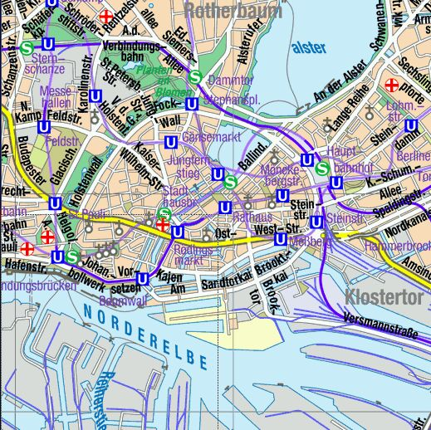
Hotel NH City
BSH
Hotel Madison
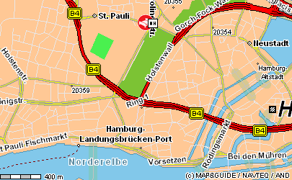
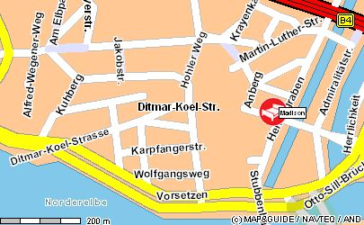
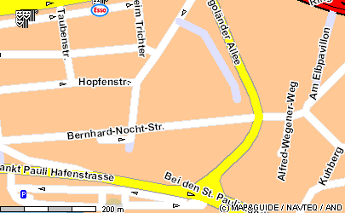
From NH City
Madison
BSH
Hotel
Hafen

From Madison

Station „Landungsbrücken“

U1, S1, S3

„-„ indicates that the hotel is within walking distance; S1 / S3 are underground trains
Hotels Hafen-Residenz and Hafen-Hamburg indicated „occupied“ but there is still a chance for single direkt bookings
There is a BSH corporate rate from 75,-EUR
well kept hotel; no car parking!
villa style hotel

